Supplement 1. Focus Group Guide

INTRODUCTION: (Approximately 5 mins)
Hello everyone, thank you for logging on today. My name is Dr. Keith Gibson, I am helping Dr. Courtney Monroe, who is a researcher at the University of South Carolina, to conduct this study.

The goal of this discussion group is to get your opinions on how we should use technology to support Black adults in increasing their physical activity (physical activity means any movement, including exercise which is planned, structured, continuous movement).

I am going to ask you some questions about your perspectives on this topic. There are no right or wrong answers, so feel free to speak openly here. Please also chime in at any time if you agree or disagree with anything that is said. Any type of feedback and honest perspectives are important and valued, and you won’t hurt my feelings!

The goal here is to start a conversation, and this is much more effective if you all participate. Before we get started, let’s do brief introductions...

GAMIFICATION: (Approximately 15 mins)

We’re going to start by getting your opinions about a research program that was already created…

Recently, Dr. Monroe led a study to get adults to be more physically active. She tested a 12-week program that people accessed by going to a website OR using a mobile web app on their smartphone.

Participants received a Fitbit, made physical activity goals, gained access to behavior change information, and got regular feedback about their progress towards their goals. Participants joined the study in teams of 3-8 people who already knew each other. The teams were combinations of family, friends, and co-workers.

The competition was set up to see which team could get the most steps in, on average, by the end of the program. Each team had a shoe mascot and could pick their own team name [SHOW LEADERBOARD SCREENSHOT]. They could also see what we call a “leaderboard,” which showed their total steps, weekly steps, and ranking compared to the other teams at any point in time.

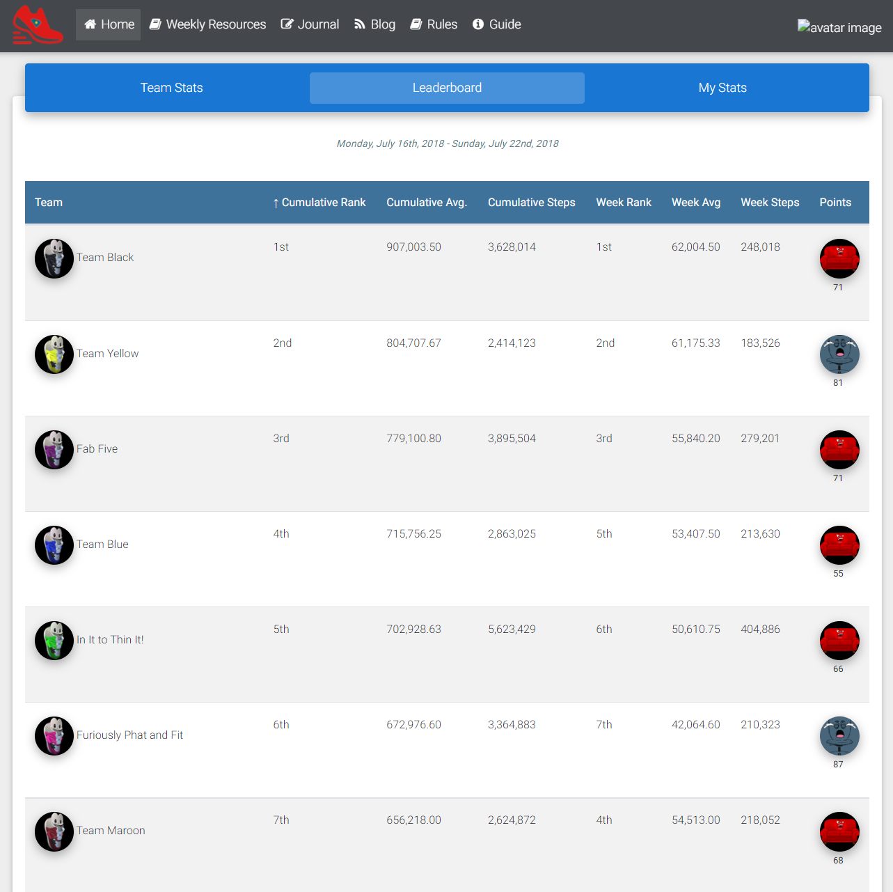

There is more to discuss but I want to get your general reactions so far…
- What do you think about a team competition like this one? How much, if at all, would this kind of competition motivate you to be more physically active? Why or why not?
- If you could pick one, what other forms of competition would you prefer, if any?
1) Leaderboard showing individual steps for everyone
2) Leaderboard showing team steps + active minutes
3) Leaderboard showing individual steps + active minutes for everyone
4) Something else other than a traditional leaderboard to present rankings of physical activity for teams
5) Something else other than a traditional leaderboard to present rankings of physical activity for individuals

- What do you think about the shoe mascot and selecting a team name – is it something you feel is important to create team unity, and in turn, would it help motivate you and your team to be physically active?
  - What types of images would you prefer to select from to represent you or your team in an online physical activity competition other than the shoe mascot (for example, something such as an avatar [an icon or figure that you can choose to represent you online in a game] or some other representation of your team and yourself, and if so, what – what would you want it to look like/represent – e.g., fitness, race/ethnicity, etc.? Or do you like the shoe mascot idea alone?

STORYLINE (Approximately 15 mins)

Participants in the earlier study also were asked to engage in a game with a storyline called the Shoe Mascot Game. Within the overall step challenge, there were also weekly challenges, we call this a Storyline. A storyline is a narrative, often times with characters and details that are threaded together. The object of the game was to keep their team’s virtual shoe mascot on the walking trail level shown here by completing two physical activity challenges each week, each with its own corresponding point value. The teams start the game with 120 points and could keep points by completing the challenges. If they did not complete the challenges, the teams lost points and eventually their mascot fell to a lower level represented by activities that involved sitting. Team standings in the game were displayed on the leaderboard. The team that won the game received a “Congratulations” message posted online that all other teams could see. [SHOW SCREENSHOT FOR SHOE MASCOT]
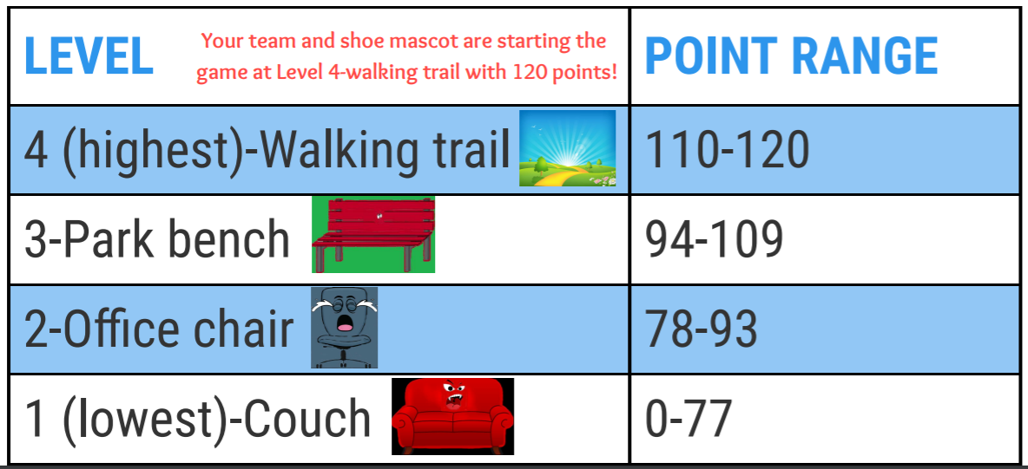

- So what do you think about this idea? How much, if at all, would you enjoy participating in this type of game with a team? How much would it motivate you to be more physically active? Why or why not?
- What do you think about a game like this one, in particular
  - a storyline?
  - levels and points?
  - weekly challenges?
  - simple recognition (a congratulations) for the winning team?

WEEKLY CHALLENGES: (Approximately 15 mins)
There were different types of weekly challenges that were presented as part of the Shoe Mascot Game. Here are some examples of challenges that were presented as part of the game. [SHOW EXAMPLES OF WEEKLY CHALLENGES].

- CHALLENGE (5 points): Each team member must achieve his/her personally prescribed Week 1 goal (obtain at least 1,000 steps above personal baseline average daily step count for the week).
- CHALLENGE (5 points): One team member will be randomly selected to see if he/she obtained at least 1,000 steps above his/her personal baseline average daily step count on at least 4 weekdays and one weekend day.
- CHALLENGE (6 points): Where are you being physically active? In order to fulfill this challenge, each team member must email a picture of where you are being active this week (park; gym; home treadmill; work; etc.) OR describe where you're being active in a Journal entry on the website.
- CHALLENGE (1 point): Your team must collectively accumulate more steps on the weekend (Saturday and Sunday) this week than you did on the weekend this past week (week 4).
- CHALLENGE (8 points): YOU CHOOSE YOUR CHALLENGE! Pick either OPTION A or B. Each team member can personally make his/her own choice, but each team member must complete at least one of these options. If you want to personally challenge yourself, you can aim to complete both of them! OPTION A. Support a teammate or teammates! Send or say an encouraging message. Inquire about how he/she is (or they are) doing and have a friendly, supportive conversation - problem solve together to overcome barriers and/or celebrate successes. Offer to cover work, chores, or other responsibilities, so he/she can take a quick walking break. Be active together. Etc. Please let us know how you supported or have been supporting your teammate or teammates. Please also let us know if you have received support from a teammate or teammates and if so, what was the nature of it? Send us your responses via the Journal or by emailing Courtney. OPTION B. Achieve 4,000 steps above your personal average daily baseline step count for this week

[KEEP READING WHILE SHOWING SCREEN] For some challenges, all of the team members had to meet a goal for the challenge to be completed that week. In other challenges, only one team member, who was randomly chosen, had to meet their step goal that week for the challenge to be completed. Other kinds of challenges asked team members to complete a challenge that was not tied to their physical activity goal directly (e.g., show the location where you are being active – with a picture). Other challenges asked the team to achieve a goal together. Some weeks, each team member chose the challenge they wanted to complete.

What types of challenges would appeal to you the most?
- Team-based
- Random selection of a team member
- Getting to choose from options
- Ones that do not focus directly on physical activity (social support; showing where you are being active)

Overall, would you be more likely to participate in a program where you were...PICK 1

- Competing against other people or teams based solely on a physical activity measure such as steps like described earlier

- Competing against other teams in the context of a game with weekly challenges like the one described earlier

- Your team tried to achieve weekly challenges (whether in the context of a game or not) but did not compete against other teams

TEAM COMPOSITION: (Approximately 40 mins)

Lets change gears here and talk about something a little different…
- When thinking about participating in an online program such as this one:
  - How important would it be to you to be in a team with people you already know? If so, who (family; friends; co-workers)?
  - How would you feel about being in a team with people you DON’T already know?
  - What qualities would you want to see in your teammates? LIST. (PROBE: what about in terms of providing motivation, support, friendship?)

  - Along those lines, whether you enroll with people you know or not, how important is it to you to have teammates who have a similar starting activity level as you? How would you feel if your teammates had different fitness levels, with some people doing better than you in being physically active and some doing worse?

  - If you were joining with a team of people you knew, how important would it be for your teammates to be the same sex?

  - What about if you were put into a team with strangers? How important would it be to you that your teammates be the same sex?

  - If you were joining with a team of people you knew, how important would it be for your teammates to be Black?

  - What about if you were put into a team with strangers? How important would it be to you that your teammates were Black?

  - How important is it to you to have teammates who live in the same geographic area as you? How would you feel if your teammates lived somewhere else but could participate remotely using technology?

  - Would you want to include someone on your team who you know who may not want to get more active themselves but who would support you? (Maybe someone who is already active or someone who does not have the time or interest in increasing their activity at that time but will be a good support for you getting more active).

  - What kind of support from a coach or other program staff expert would you want, if any? PROBE: IF YES: Would it be important for that person to be like you in terms of race/ethnicity or in sex or do you not have a preference as long as they are knowledgeable and supportive?

- Is there anything else anyone would like to add based on what we have talked about today?
- Probe on race/culture if organically arise.

* * *

