**Supplementary Material – Sample questionnaire**

**Date of procedure:**

**Location:**

Endoscopy □

ICU □

Ward □

**Scope Used:**

AMBU aScope HD 5.6/2.8 □

AMBU aScope 5 HD 5.0/2.2 □

AMBU aScope 5 4.2/2.2 □

AMBU aScope 5 2.7/1.2 □

**Sticker**

**Name:**

**DOB:**

**MRN:**

**Indication:**

**Covid status:**

Positive □ Negative □

**Procedure:**

Airway inspection □

**Complication:**

Scope handle break □

Suction connector break □

Image failure □

Other □

Requirement to switch to reusable scope □

Requirement for second SUFB □

Description:

BAL □

Washing □

Brush □

Endobronchial biopsy □

Transbronchial biopsy □

Transbronchial needle aspiration □

Cryobiopsy □

[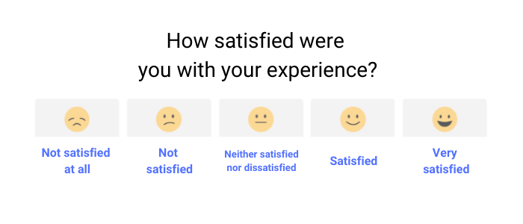](https://www.google.com/url?sa=i&url=https://boast.io/csat-vs-nps-which-is-best/&psig=AOvVaw3cUpfZNdImJsCJqxBTFo_a&ust=1612012990662000&source=images&cd=vfe&ved=0CAIQjRxqFwoTCODZk8yewe4CFQAAAAAdAAAAABAG)

APC □

Electrocautery □

**Participant characteristics**

|  |  |  |  |  |
| --- | --- | --- | --- | --- |
| **Date of procedure** |  | | | |
| **Procedure completion** | Yes | | No (please elaborate) | |
| **Gender** | Male | | Female | |
| **Hand** | Left | | Right | |
| **Occupation/Grade** |  | | | |
| **Number of years performing bronchoscopic procedures** | | |  | |
| **Number of bronchoscopic procedures performed within the past year** | | |  | |
| **Location** | Endoscopy unit | ICU | | OR |
| **Size selection**  aScope™ 5 Broncho | 5.6/2.8 | | 5.0/2.2 | |
|  | 4.2/2.2 | | 2.7/1.2 | |
| **Indication** | Airway inspection | | BAL | |
|  | Washing | | Brushing | |
|  | Endobronchial biopsy | | Transbronchial biopsy | |
|  | Transbronchial needle  aspiration | | Cryobiopsy | |
|  | APC | | Electrocautery | |
| **Adverse events** | Yes (please state) | | No | |

**Workflow and bronchoscope performance assessment (please circle)**

|  |  |  |  |  |  |
| --- | --- | --- | --- | --- | --- |
|  | Very Poor | Poor | Average | Good | Very Good |
| Workflow | 1 | 2 | 3 | 4 | 5 |
| Instrument passage through the working channel | 1 | 2 | 3 | 4 | 5 |
| Image quality | 1 | 2 | 3 | 4 | 5 |
| Overall | 1 | 2 | 3 | 4 | 5 |