ype: | Security Manual
Applicable to: | Enterprise-wide
Process owner: | STOP Intimate Partner Violence Task Force (Ashlee Murray) and Security Department (Joe Potterton)
Effective Date: | August 2020
Supersedes: | N/A
Approved by: | <List the title of the document approver (body or person) here>
Document ID #: | < Manual Coordinator will provide assistance with document ID numbering>
Accountable for: | <The person with the highest level of accountability for oversight of this policy should sign in this space; discuss with Manual Coordinator>  <Enter the title and credentials of the individual underneath their signature>

- Purpose

To outline the steps for when the security department responds to incidents in which individuals are experiencing intimate partner violence (IPV), a type of family violence. Appropriate response by security officers will include:
- Ensuring safety for all individuals involved
- Referrals to appropriate resources
- Maintaining confidentiality
- Reporting to local law enforcement

2 Definitions
Term | Definition
Family Violence | Sometimes called domestic violence, is defined as acts of violence between family/household members, including adult partners, a parent against a non-minor child, caretakers or partners against elders and between siblings.
Intimate Partner Violence (IPV) | A range of behaviors between intimate or dating partners which manifest as a pattern of purposeful coercive behaviors that may include inflicted physical injury, psychological abuse, sexual assault, progressive social isolation, stalking, deprivation, intimidation and threats. The attempt to control another person may also manifest as forcing a person to be financially dependent on them for essentials of life such as food, clothing, shelter, or medical care.  These behaviors are perpetrated by someone who is, was or wishes to be involved in an intimate or dating relationship with an adult or adolescent victim and are aimed at establishing control of one partner over the other. It can occur among individuals in the same household or family, or non- household partners. It can occur between adolescents in an intimate relationship (sometimes referred to as “teen dating violence”).
Power and Control | The concepts of Power and Control refer to the pattern of abuse and violence in intimate partner violence. It recognizes that intimate partner violence is an act of power and that perpetrators use specific behaviors to establish and maintain control over their partner, including, but not limited to, economic abuse, isolation, intimidation, coercion and threats.
Mandated Reporter (Pennsylvania) | Within the state of Pennsylvania, a mandated reporter is defined as a person who has a reasonable cause to suspect that a child is a victim of abuse or neglect, including a person who is licensed or certified to practice in any health related field under the jurisdiction of the Department of State; an employee of a healthcare facility who is engaged in the admission, examination, care or treatment of individuals; clergy, priest, rabbi, minister, Christian Science practitioner, religious healer or spiritual leader; hospital attorney.
Reporter (New Jersey) | Within the state of New Jersey, a reporter is defined as any person having reasonable cause to believe that a child has been subjected to abuse or acts of abuse in New Jersey.  To make a report of suspected child abuse or neglect, call 1-877 NJ ABUSE (1-877-652-2873).  Please refer to Policy: Suspected Child Abuse or Neglect for Patients Seen in New Jersey and Procedure: How to Report Suspected Child Abuse or Neglect for Patients Seen in New Jersey.
ChildLine (Pennsylvania) | Pennsylvania’s statewide reporting includes an online portal and a hotline (1-800-932-0313) to make reports. Please refer to Policy: Suspected Child Abuse or Neglect for Patients Seen in Pennsylvania and Procedure: How to Report Suspected Child Abuse or Neglect for Patients Seen in Pennsylvania.

3 Procedure

Ensuring Safety
Purpose
To establish safety for everyone involved in an incident of IPV, including employees, security officers, patients, families, caregivers, and surrounding colleagues.

GUIDELINES
- When addressing IPV in this setting, the parties involved should be separated. Do not address incidents of IPV with the alleged perpetrator and victim together.
- It is important to recognize that with incidents of IPV, child abuse may be occurring.
- IPV should not be discussed in front of children 2 years of age and older.

NOTE:
- Merely witnessing IPV in the home is not considered abuse or neglect in the state of Pennsylvania. Involving Child Protective Services inappropriately may escalate danger and cause further trauma to children in the home. For additional guidance, please refer to procedures: How to Report Suspected Child Abuse or Neglect for Patients Seen in Pennsylvania and How to Report Suspected Child Abuse or Neglect for Patients Seen in New Jersey.
Required Action Steps | Supplemental Guidance
- Immediately notify your supervisor (Sergeant or Corporal) and the manager or staff leader of the relevant unit (floor, clinic, office, surgical suite) of your concern. Do not respond to the situation alone. | - Suspected Child Abuse or Neglect  - Policy: Intimate Partner Violence  - Violence in the Workplace Policy  - Domestic or Sexual Violence Leave Policy
- Maintain a safe distance from the individual allegedly perpetrating the violence. | Refer to Job Aid:  - Potential for Violence  - De-escalation Techniques
- Separate the parties involved and remove the alleged perpetrator from patient care as a precautionary measure. In order to enforce a Protection from Abuse (PFA) order, the individual with the PFA must have a physical copy present. | - Policy: Visitation of Patients  - Procedure: Visitor Restriction  - Policy: Intimate Partner Violence
- Obtain as much information about the incident as possible, using the guiding questions of “who, what, where, when, why?”
- Social work shall be notified, as they will assess the need for restrictions. If applicable, social work will also refer to the IPV specialist.
Referral to Resources
Purpose
To provide support for the individual experiencing IPV and managing secondary traumatic stress in individual responding and/or witnessing IPV.

GUIDELINES
- If the client has screened positive for any IPV screening, ask the client if they would like information about resources or a referral to an IPV specialist. Any adult or adolescent who has been a possible victim of IPV has the right to refuse assistance. However, if an adolescent minor is the victim of IPV with an adult partner, this IPV must be reported as child abuse under the Child Protective Services Laws in Pennsylvania and in New Jersey.
- If the survivor of IPV expresses that they do not need help, it is a trauma-informed response to respect their wishes. Unwanted intervention may put the individual(s) and their family more at risk and can perpetrate the “power and control” cycle. (Job Aid: Implementing a Trauma-Informed Approach)

Required Action Steps | Supplemental Guidance
- Ask the survivor if they are interested in obtaining referrals and resources. | - Intimate Partner Violence Screeners Job Aid
- Contact information for the IPV Counselor shall also be provided to the individual experiencing IPV. | - Referral for IPV Counselor  - Philadelphia Domestic Violence Hotline  - National Domestic Violence Hotline
- The responding security officer is expected to verbally provide information for the Employee Assistance Program for employees experiencing IPV. | - Link to Employee Assistance Program  - Link to Care for Colleagues  - Link to Human Resources  - Domestic or Sexual Violence Leave Policy
Maintaining Confidentiality
Purpose
To ensure the confidentiality of the person experiencing IPV and thereby safety of all persons involved.

GUIDELINES
- Privacy refers to the right of the individual to keep their health information private, while confidentiality refers to keeping shared health information confidential from those who do not need to know. Information should not be shared with any individuals who are not directly involved and/or responding to the incident.
- Maintaining confidentiality also applies to the documentation and reporting.
- The security supervisor on duty should assess the need for a debriefing session among officers who were involved in a potentially upsetting, stressful event.
Required Action Steps | Supplemental Guidance
- The incident should only be documented in the online Incident Reporting form. Any notes should be shredded and placed in the HIPAA compliant bin. | - See image below for Investigation Report example.
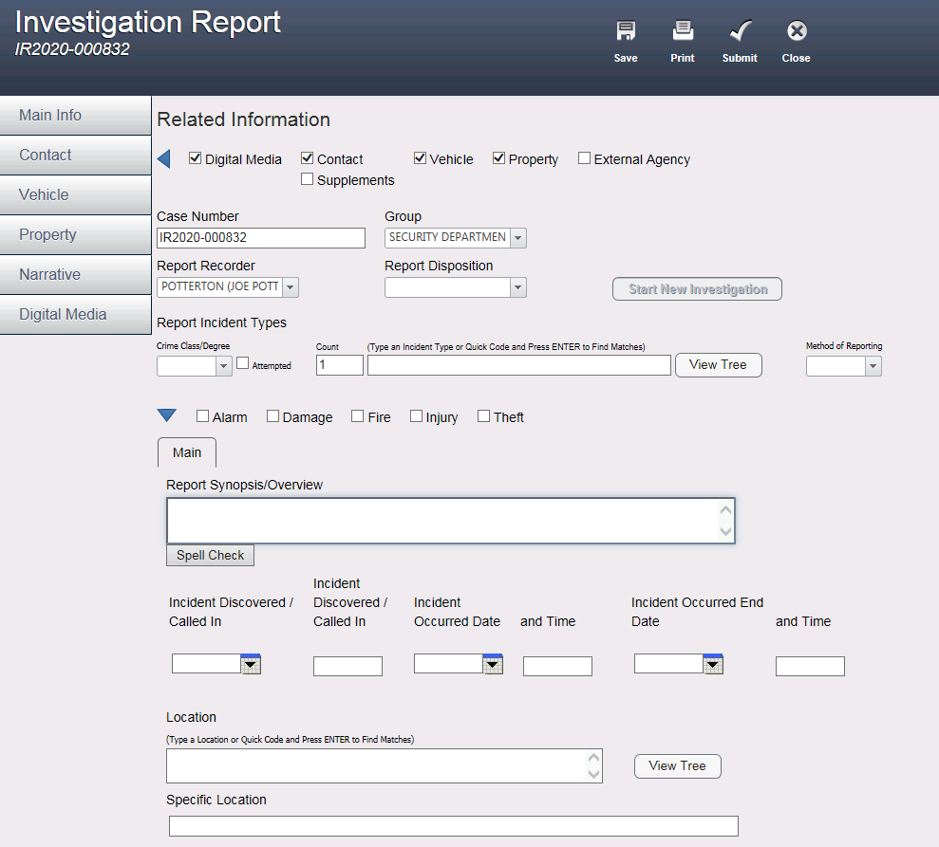

Reporting to Local Law Enforcement
Purpose
To define the parameters of when security officers must report incidents of IPV to local law enforcement.

GUIDELINES
- The states of Pennsylvania, New Jersey, and Delaware do not have to report incidents of IPV unless a weapon is involved. It is important to recognize that in some instances, reporting to law enforcement may inadvertently place the person experiencing IPV at higher risk of danger and harm.
- Security has measures in place on how to appropriately respond to a situation in which a weapon is involved. (Link to policy)
Required Action Steps | Supplemental Guidance
- There are 3 main situations when security officers must engage local law enforcement:  - When the alleged perpetrator poses immediate danger to patient, caregiver/family member, or employee (e.g. trespassing)  - When a deadly weapon is used  - To initiate a chain of custody for physical violence | - Futures Without Violence: Mandatory Reporting of Domestic Violence to Law Enforcement by Health Care Providers
- The responding security officer may consult with the IPV specialist on how to appropriately respond. | - Referral for IPV Counselor  - IPV Safety Planning Job Aid
- The security supervisor on duty may debrief with the security officers and staff members who responded to the incident to better inform future response, safety planning, and initiate mental health assistance. The IPV specialist’s presence can be requested for these debriefings. | - Employee Assistance Program

4 Related Documents

Document Type | Document Name
Policies | Patient Care Manual  - Intimate Partner Violence  - Suspected Child Abuse or Neglect for Patients Seen in Pennsylvania  - Suspected Child Abuse or Neglect for Patients Seen in New Jersey  - Evidence Preservation  - Adult Protective Services Law (APS) Act 70 of 2010  Human Resources Manual  - Child Protective Services  - Rules of Conduct  Administrative Policy Manual  - Confidentiality of Patient and Institutional Information  Administrator On-Call
Procedures | Patient Care Manual  - How to Report Suspected Child Abuse or Neglect for Patients Seen in Pennsylvania  - How to Report Suspected Child Abuse or Neglect for Patients Seen in New Jersey  - Responding to and Reporting Allegations of Suspected Child Abuse or Neglect when an Employee is Named as the Alleged Perpetrator  - How to Report Suspected Adult Abuse or Neglect for Patients Seen in Pennsylvania  - Responding to and Reporting Allegations of Suspected Adult Abuse or Neglect when an Employee is Named as the Alleged Perpetrator
Job Aids | De-escalation  - De-escalation Techniques  - Implementing a Trauma-Informed Approach  - Potential for Violence: Indicators, Interventions, Resources  Intimate Partner Violence  - Intimate Partner Violence Safety Planning  Adult Abuse  - Indicators of Suspected Adult Abuse or Neglect  - Summary of New Jersey Adult Protective Services Act  Child Abuse  - Indicators of Suspected Child Abuse or Neglect  - Summary of the New Jersey Child Protective Welfare Law  - Summary of Pennsylvania Child Protective Services Law  - Interpretation of Mandatory Reporting Laws Under the Child Protective Services Law and the Crimes Code
Regulatory References | <list applicable regulations; delete if not applicable>

